Low Ropes Description & Guidelines

Description: Low Ropes is a time when groups/cabins work together to accomplish a common goal given to them by the facilitator. It is important to remember that the purpose of a Low Rope Exercise is to:
1. Encourage good communication within the group
2. Building into their group bonding
3. Help them work together as a group
4. No put downs should be tolerated
** we are all created different sizes & shapes- but we are a team. Help each other, cheer for each other.

Sequencing

For the Oldest Groups:
Day 1: Start with some of the easier Low Ropes, explain why we are doing these as a group.
Hoola Hoop Pass/Square Rope/Magic Carpet/LineUp
Day 2: Begin the harder elements.
RR Tie Walk/ Gilligan’s Island
Day 3: Continue with harder elements.
Meat Grinder/Poles Apart
Day 4: Finish and debrief the week.
Whale Watch/Spider Web/Weeble Wobble

For the Younger Groups:
Day 1: Magic Carpet, Hoola Hoop Pass, RR Tie Walk
**On Wednesday in Slot #3 you will have 2 groups- you can do them together up at the gym alternating activities

Day 2: Poles Apart, Meat Grinder, Whale Watch, Spider Web
**you may need to check with the HC’s to make sure you are not using the same elements as them.

ENDING QUESTIONS:
How did you feel during this activity?
What did you notice about your group? Who were the leaders? Who had the most ideas?
Did you work together well?
What made you work together well/ not work together well?

Low Ropes Guidelines

Beginning Low Ropes
- Name Game with multiple balls-establish an order, continue passing/adding balls, must start over if any balls are dropped, object to get several balls moving(over 20 is possible). Group cannot change the order, switch places. Can change size of circle, throwing/tossing is not a must---handing off is okay. Give group hints about smarter ways to get task done, but don’t come out and tell them.
- Limited senses-everyone is blindfolded and mute-assign a number to each secretly/or have them get in order alphabetically first/last name/musical group, whatever. You could also do it no talking w/o blindfolds.
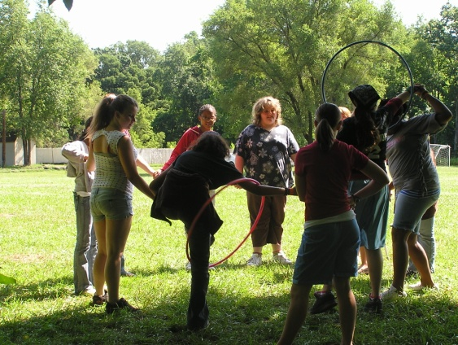
- Rock, Paper, Scissors Group style-split into 2 teams-review rules for RPS-two groups line up facing each other-each group picks one sign-they come together and face off-group that loses must run to a certain point before being tagged by winners. If losers get tagged they switch sides. Repeat as many times as you wish. I do it for about 10 minutes.
- Hoola-Hoop Pass- Group will join hands with a hoola hoop over one set of entwined hands. They will need to pass the hoola-hoop around the circle without breaking hand holds.
- Instigator (one foam noodle for each group of 3)-Have group split into multiple groups of three. Each group is only playing within their own group. There are 3 jobs within each group. Job #1-“Instigator”-they are attempting to swat (not beat) the “victim” on the legs as many times as possible. #2“Victim”-they are trying not to get hit by the “instigator.” #3 “Protector”-they are trying to protect the “victim” from getting hit by the “instigator” by either blocking “instigator” or running with the “victim.” Stress that they need to perform their job to the best of their ability. Assign first round of jobs. After approx. 15-20 seconds of playing, switch roles w/in each group so that each person gets to do each job. After completion, give a water break! This activity is one that you MUST debrief at some point during the activity. You should talk about individual/group roles in real world settings (job, family, school, etc.). Talk about how your role as an individual plays a part in group settings. Talk about being aware of how other people have different roles/ways of communicating/responding to communication than you do (i.e.-instigator vs. victim). Talk about using your role as an individual to help the group as a whole. Encourage them to be thinking about their role(s) throughout the week.
- Square Rope-Everyone needs to be blindfolded-its good to make them sit down while doing this so they won’t create drama. Place a rope on the floor. Instruct the group to 1) find the rope, 2) all grab ahold of rope, 3) make a square out of the rope.
- Magic Carpet- group will stand on a blanket and need to turn the blanket completely upside down without anyone stepping off the blanket.
- Don’t touch me-Have group members grab a partner and stand across from them in a circle-- the end result should be a circle w/ partners across from each other. Place a cone in the center of the circle-There are 4 objectives to this activity that they must complete. 1. Everyone must touch the cone (at once or diff. Times-they are allowed to pick up the cone but don’t tell them that right off) 2. Everyone must switch places with their partner (this activity has a lot of ‘wavering’ room-ie, they don’t have to stay in a circle, but don’t tell them that-let them ask) 3. No one can touch anyone else while they are touching the cone/switching places 4. Everyone must say “don’t touch me” once, when they are completing the last 3 objectives. Lastly, this activity is timed. Have them formulate a plan before beginning, give them several trial runs, time them a few times-encourage them to get the best time they can. Depending on their plan-you could have times of less than a second.
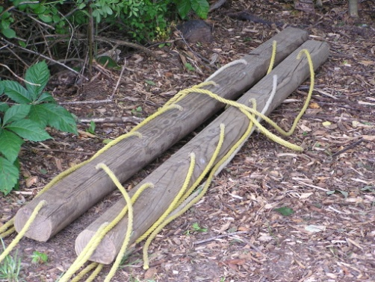
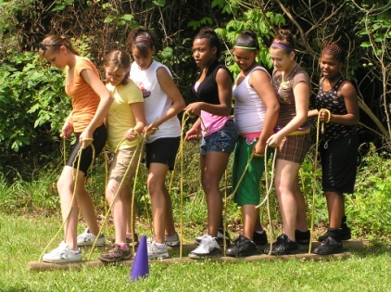
- RR Tie Walk- Groups will be given the set of RR Ties with ropes and need to ‘walk’ on them with the whole group from a starting point to an ending point.

- Minefield-Make a square w/ cones for corners-you should have 10-15 feet length sides. Inside the square make a mess w/ little balls/basketballs/really any supplies you have. For this task, partner pairs (one of the partners is blindfolded) must direct one another through the “maze” of crackerjack-from one side to the other. The non-bf person must stay on one end of the maze, they are only allowed to give verbal assistance. If the blind person hits a ball, they start over. Instruct them to lift up their blindfold to walk back-sounds simple, but most don’t. Once they have completed, have partners switch blindfolds and do it again.

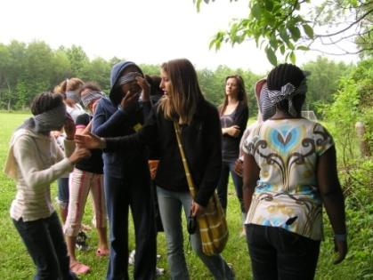
- Trust walk—There are several different versions of this activity. 1. Blindfold group, have them hold hands, counselor (w/ sight) leads them on a path all over camp. 2. BF group, tie in a circle, have them direct themselves from far far away (field) to the lodge, you and counselors warn them of anything they might hit. 3. BF group, take them far far away (past archery), require them to find their way back by following the sound of your/counselor’s voice. Make sure to debrief this activity (ideas-sin, listening to counselors, etc.)

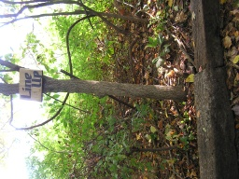
- LineUp- Group must get onto RR Tie and rearrange in various orders depending on leader- ie. Arrange in birthday order, alphabetically by first name. You can have the returning camps be mute

Low Ropes Requiring more Trust
- Human Knot- Group stands in a circle and is instructed to grab hands with two different people. This ‘knots’ them up together. They are instructed to untangle themselves without anyone breaking hands.

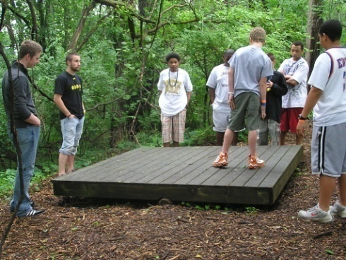
- Whale Watch-Goal is to get entire group on platform and balance it for thirty seconds, then they will “see the whales” (the story behind the activity is that they are in the ocean, looking for whales, but their boat-the platform-is a beater). Rules-1. They can only enter from the 3 center boards on either side (more than one person can enter at once-optional) Those are the only entrances. 2. They must pick 2 people-any 2, can even switch whenever-those two must get on first and balance it (no more than 2). You can balance by standing anywhere in anyway (standing, sitting, dancing, crouching, etc.). If, at any time, after the 2 people have balanced it, the platform hits the ground-everyone must start over. Weight is not a huge issue, its more about your position on the platform. They may not use anything but the platform/each other to help. Actually, tell them that holding on to each other does help them to feel the shifting of the board better-and it’s easier. Once they are all on, start timing. MOST IMPORTANTLY, tell them not to play on the platform-when the platform hits the ground it damages the wood and shifts the platform ie making it harder to balance DO NOT ALLOW THEM TO SHIFT IT BACK.

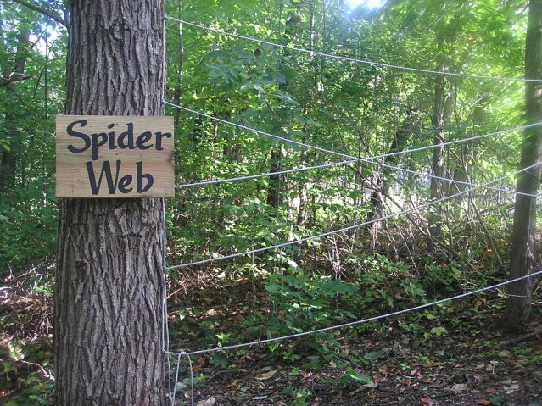
- Spider Web-Goal is to get entire group from one side of web, through, and to other side. They can’t go over/under/or around-just through. If at any time, someone going through a hole touches the web, everyone starts over. If someone passing someone else through a hole touches the web, everyone does not have to start over but tell them to limit how much they touch. They are not allowed to change the size of the holes. Once a hole has been used, it is closed. Until, 3 people have made it across, then they can choose one hole to reopen for a one time usage ie it doesn’t stay open. They can open the same hole multiple times, depending on how many people they have. Tell them to think about who is going first/going last. They will be lifting people-very few people actually make it through on their own. Instruct them, if they are not being passed through, they should be helping to pass people through. MOST IMPORTANTLY, tell them to be extremely careful around the spider web-one wrong trip on the rope WILL tear down half the web-and it will be a time for you to put it back together. Lastly, tell them not to leave all the heavy people on one side-that is stupid. Have counselors do this activity too-at least as lifters, it is up to your discretion as to whether or not they can be put through. Whatever will benefit the group most should be done.

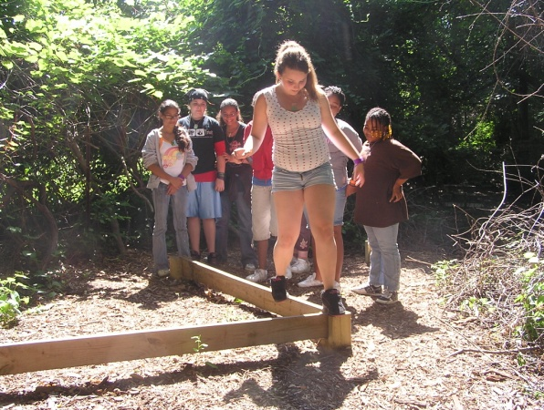
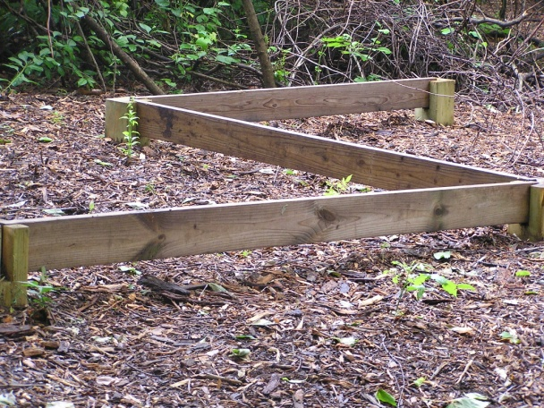
- Balance Walk-Goal is to get entire group from behind post, up on the balance beam and across, down of other side of balance beam. Group members can only assist each other from behind the beam, and on the beam. Once they have jumped off the end, they are done. The catch-they all have disabilities. You will think them up way before hand-I usually choose disabilities based on what is going to help the group most, things the individual needs to learn. For example, people who are loud/stars of the show-are normally blind and mute-it will help the group and they need to learn how to follow. Disabilities are in effect as soon as you announce them ie mute people can’t ask questions-tough luck. Other disabilities include lack of arms/legs/paralyzed person (very hard)/legs tied together/blind/mute/can only communicate through writing letters on a chosen person’s back-mix it up. Don’t make it too hard-but really this is a very effective activity-assign disabilities well. Mix it up. Do what is best for the group. Make sure you debrief-talk about jobs/tasks we have in life-we don’t always like them, but they have to get done. We have to learn how to adjust and work with one another/communicate/sacrifice our desires for the bettering of the group/getting the task done. Make sure that you get feedback for all the harder activities on things the kids did well/not so well-what to work on next time. You want the kids to be actively involved in discussion at the end until you are telling them the main lesson.
- 5 Point Balance Walk-5 posts connected by 3 boards (boards are able to be moved between the 5 posts). The goal is to get your entire group through the entire length of the balance beam. This will require them to move boards to reach the final posts and move the group across. Uses above location with a different exercise.

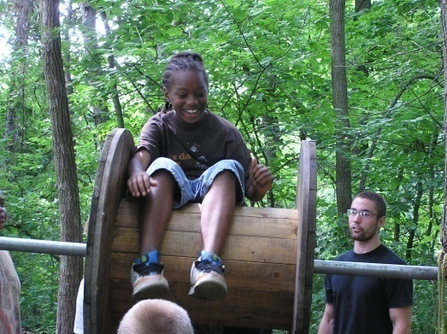
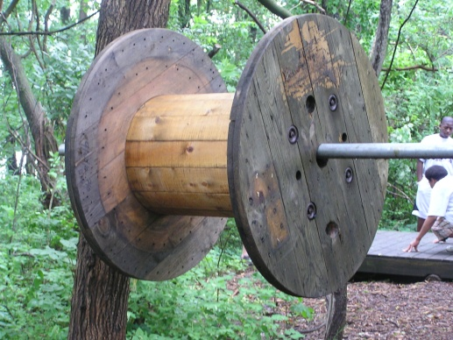
- Meat Grinder-Goal is to get whole group OVER meat grinder to other side. They are not allowed to touch the sides of the meat grinder at any time. Think about who is going first and last ie first person cannot go head first, but last person will. They can grab the hands of the person coming over on the other side, as long as they don’t touch the sides.

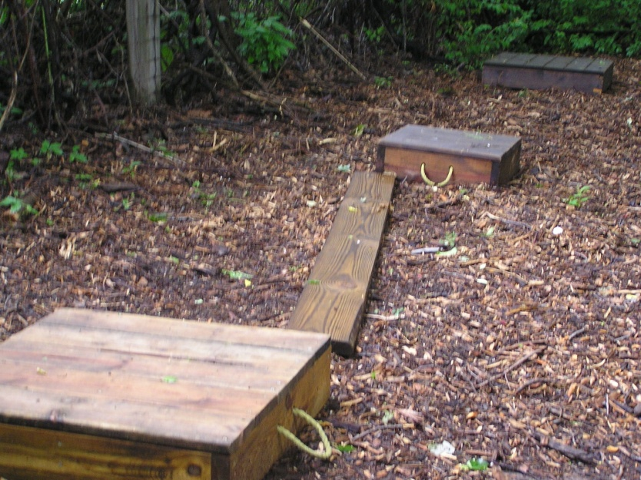
- Gilligan’s Island-Goal is to get whole group from biggest platform to middle to smallest platform using the platforms and board. The distance between platform should be approx. 6 inches longer than the board. Feel free to tell the kids that the board is too short. The board/people cannot touch the ground at any time or everyone starts over. The task does not start until everyone is on the biggest platform, board is picked up. Do not allow them to hold the board with their hands, on one side, while others cross-too dangerous-never works. Do not tell them, but the key is to have all the weight on the part of the board (on the platform) someone crosses and jumps to the other platform. They can pass the board from one platform to the other.

- Noah’s Ark- Using the middle above platform- have the group get completely on the platform with no one touching the ground. Be aware of safety- people being pushed or falling off. They must stay on the platform for at least 2 minutes.

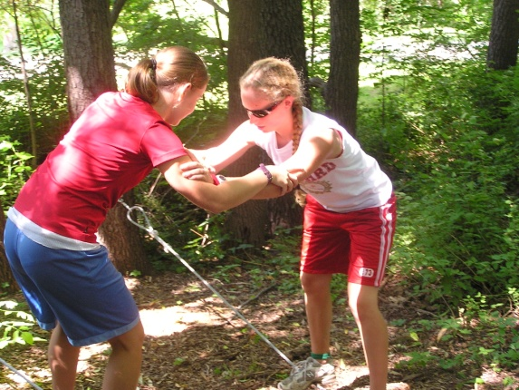
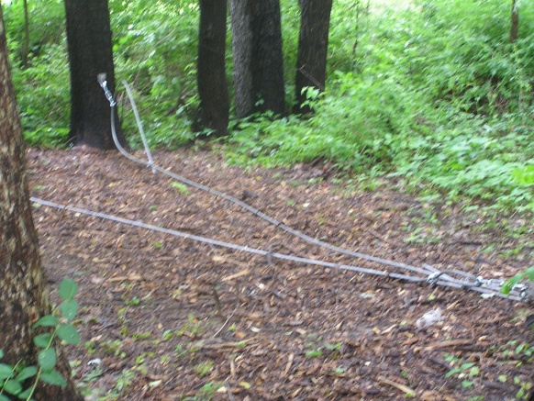
- Weeble Wobble- Everyone needs a partner of approx. same height (weight is not as important as height). They will both step on the wire (one on each wire), interlock fingers, palms together, and walk down together as far as they can. Anyone not on the wire must be spotters ie ready to catch but not touching the person on the wire, you will be in the middle directing them. Strategy-each partner must lean all their weight on the other person’s palms. Do not bend your back/ do not stick your booty out/you should be as straight as a board. Once they are pretty far out, have them lock elbows/arms straight up/leaning weight on each other. Instruct them to communicate w/ each other about more/less weight on me/you etc. You need to be instructing them the entire time, I usually hold both arms closest to me to help them/instruct them/feel if them are pushing weight on each other. Feel free to demonstrate w/ someone on the ground. With this one I normally talk about the importance of strong Christian friends-give them time to pray with their partner-talk about fears/struggles/prayer requests-and pray for one another.

- The Cargo Net- A chance for your group to practice cooperation. The object is to get the group up, into and across the element safely while transporting a "disabled" member of the group. You can also have no one disabled if this seems easier for your group to accomplish.

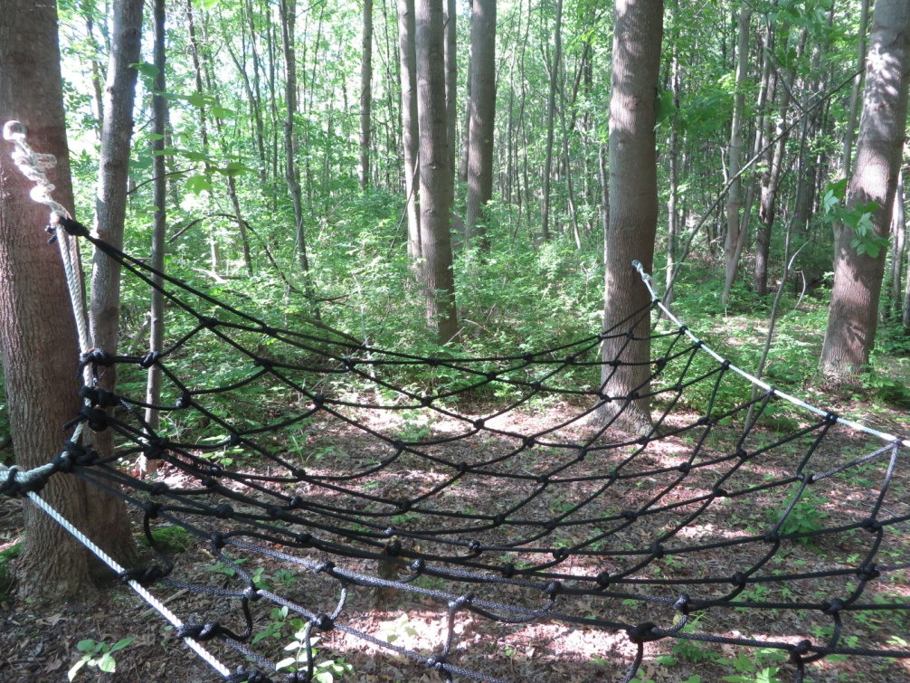

- The Fidget Ladder- Passage across this ladder is not easy. A swamp lies underneath that could engulf the nervous participant. Only hands and feet may touch the rope. Spotters required along the length of the ladder.

